ASSIGNMENT . 3

MUHAMMAD **MUJTABA**

SP22-BSE-036

DISCRETE STRUCTURES

MAM MEMOONA MALIK

DATE: Jan 1, 2023

Question . 1

(a)

1. 18 x 325 = 5850
2. 18 + 325 = 343

(b)

* The format of license plates is either **LL DD or LL DDD or LLL DDD or LLL DD**
  + So we have total **20,077,200** plates possible.
  + We did this by replacing **L** with 26 and **D** with 10 and summed all of their 4 combinations:

(26*26*10*10 + 26*26*10*10*10 + 26*26*26*10*10*10 + 26*26*26*10*10)

= **20,077,200**

Question . 2

1. = n! / r! (n-r)! = 25! / 4! (25-4)! = 12650
2. = n! / (n-r)! = 25! / (25-4)! = 303600

Question . 3

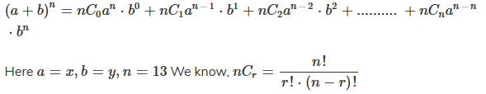

So in our case, n = 13, currentTerm k = 8 so coefficient will be:

= 13!/(8! * (13-8)!) = **1287**

Question . 4

Vertex count: 5

Edge count: 8

Degree sequence: 3,3,3,3,2 = 3,3,3,3,2

Mapping: 3,3,4,4,2 = 3,3,4,4,2

U1 = v1, u2 = v5,

u3 = v2, u4 = v3, u5 = v4

this is isomorphic because all above are same.

Question . 5

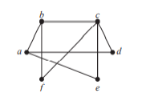

this is not a biparte graph because assigning



vertex **f** to either of the groups will lead to the



corresponding edge still joining to both of the sets.



Question . 6

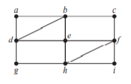

Yes it exists:

A,b,c,f,e,h,

G,d,e,h,f,e,

B,d,a

Question . 7

1. 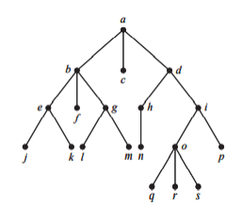**a**
2. **e,b,g,d,h,i,o**
3. **j,k,f,l,m,c,n,q,r,s,p**
4. null
5. **d**
6. **p**
7. **g,b,a**
8. **e,f,g,j,k,l,m**